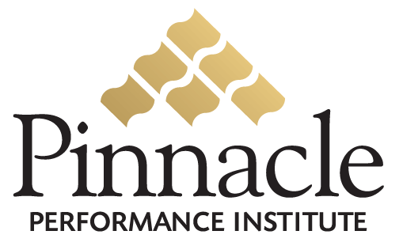

Qualified Professional

Are distributors qualified to represent the company?

Are distributors equipped to excel at their responsibilities?

Are distributors trained and certified on regulatory requirements?

Would you like to protect the reputation and brand of the company
from legal liabilities due to unauthorized product claims,
earning statements, and business practices?

Business Assistance

Do distributors have a proven formula for success
to create sales, develop marketing, and manage the business?

Do distributors have business assistance
to help lift the burden of supporting a successful business?

Distributors can have

Access to Unlimited Assessments

To Measure Strengths and Weaknesses

Unlimited Access to the Pinnacle Training Buffet

And all Industry / Business Specific Training

Distributor Support Search Engines
To Build Confidence and Competence

Effective Communication Programs
To enable Team Collaboration

Company and Individual Goal Management

Leadership Mentoring Program
To establish Accountability for a culture of execution

Free 14-Day Performance Membership
Free Membership w/ 5 Referrals
$29.95 Retail
$26.00 Wholesale
$0.25 Development Membership

